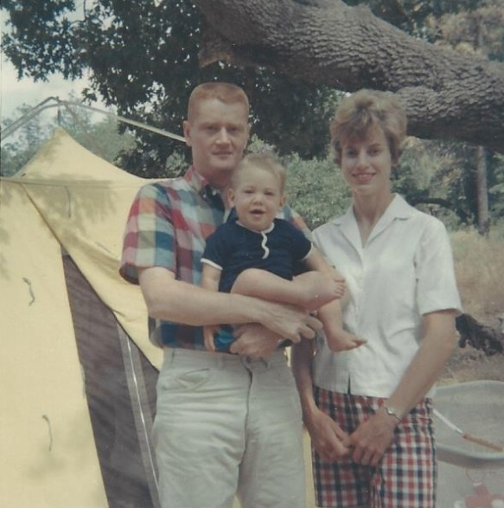

Jack, Brian & Mary Jo Moore – 1967

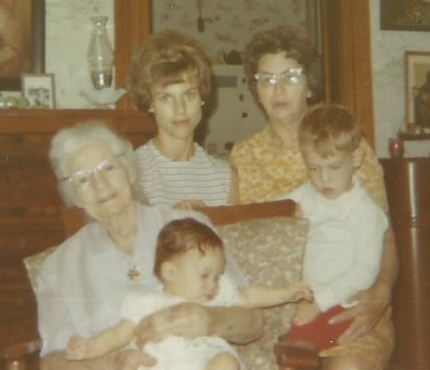

Josephine Sybil Worthen Wolfe holding Elaine Moore, Mary Jo Moore,

Mary Foster Wolfe with Brian Moore - 14 Sept 1969